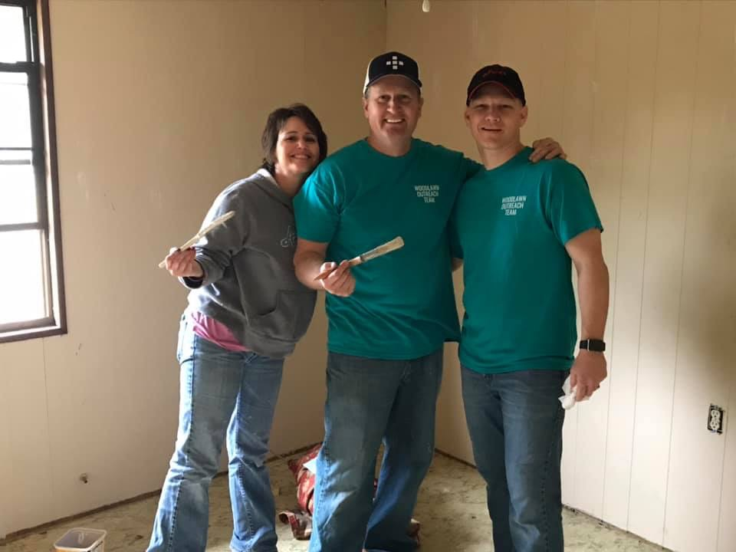 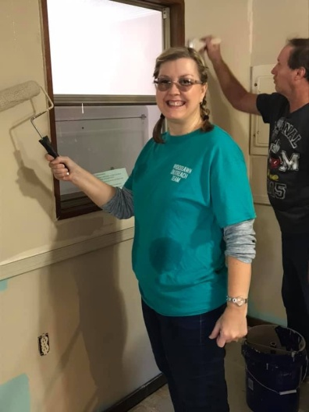 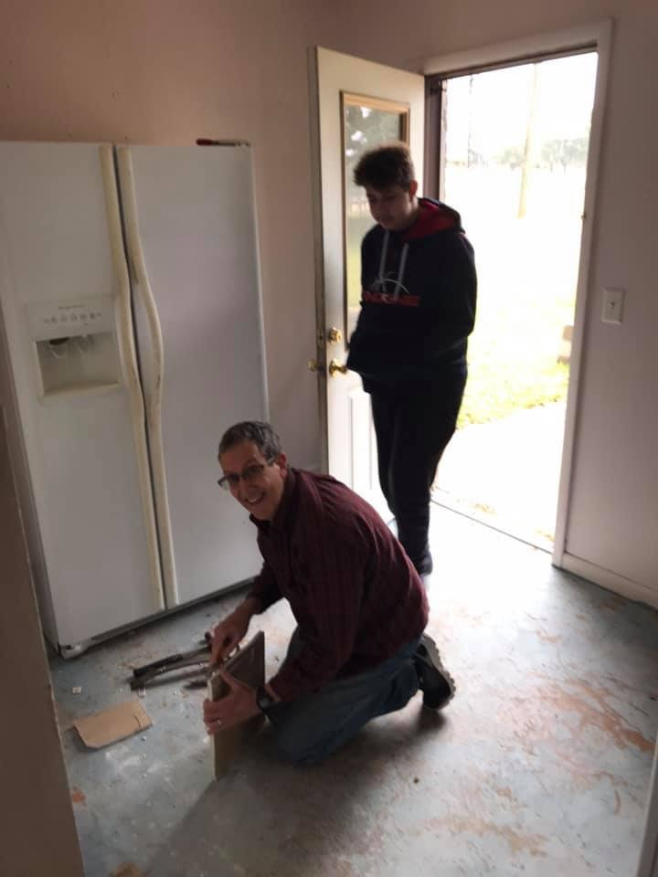 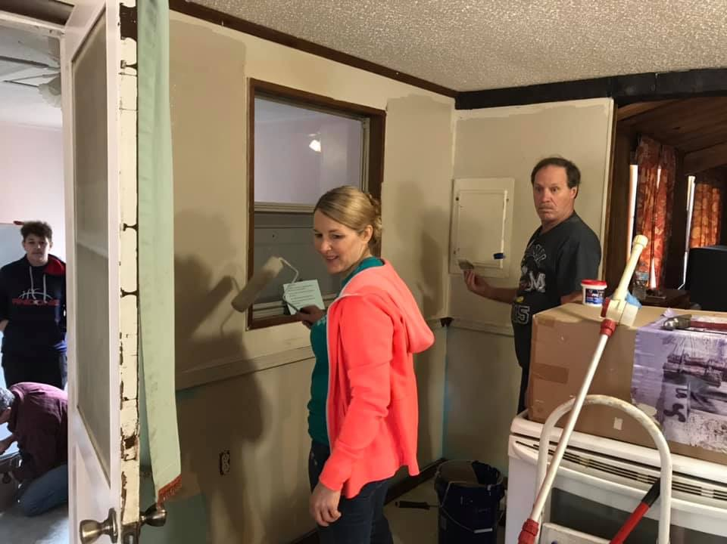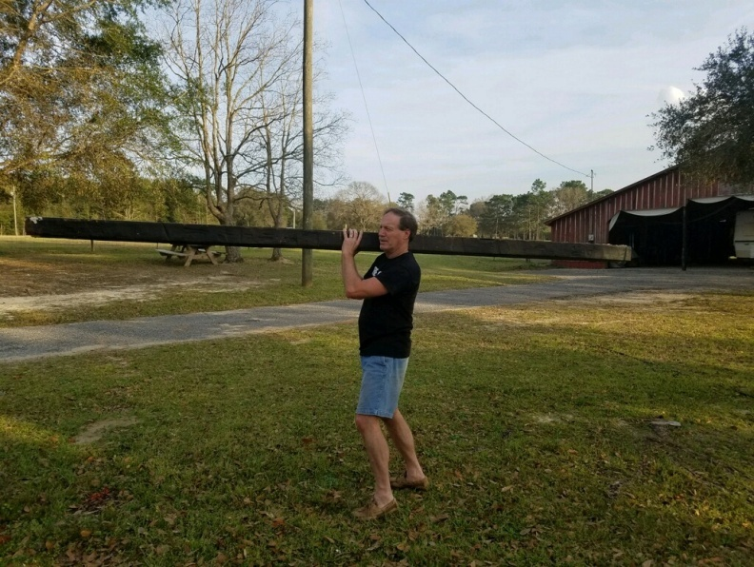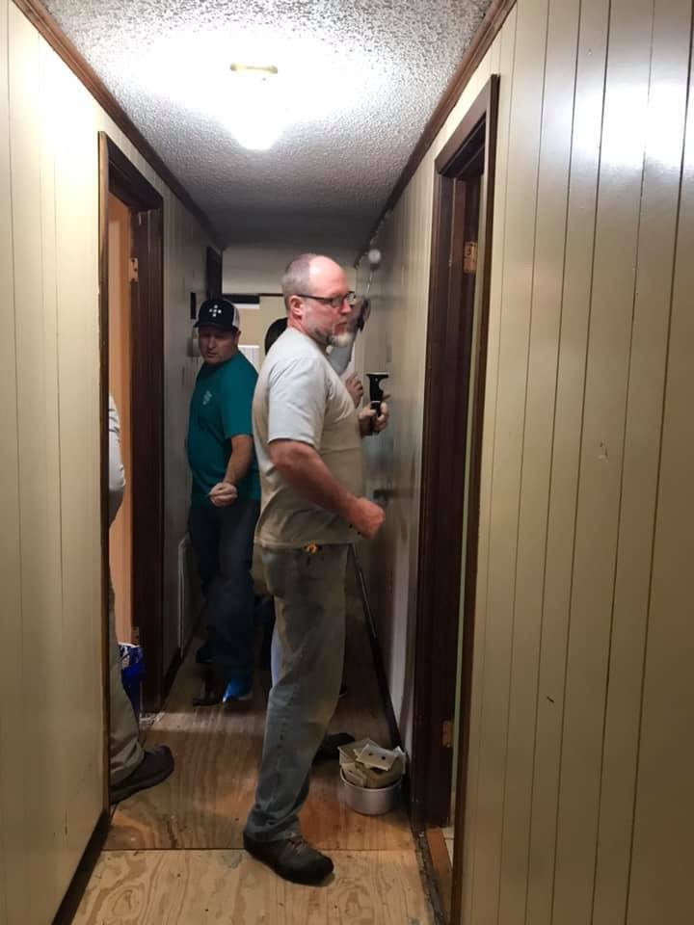 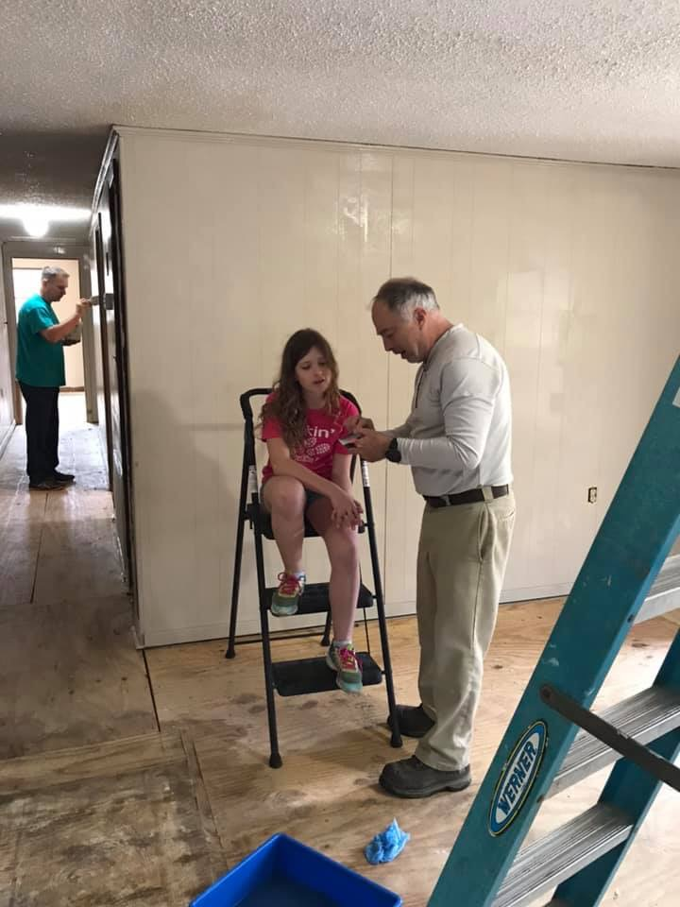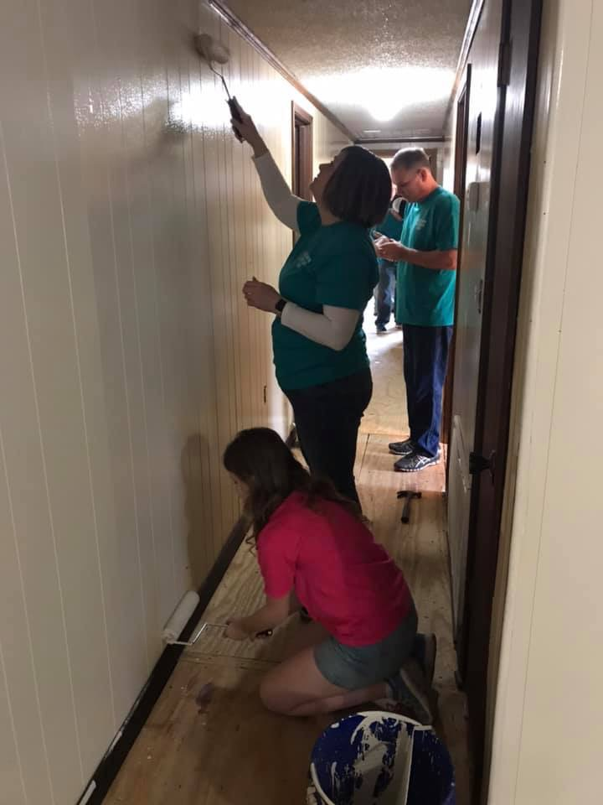 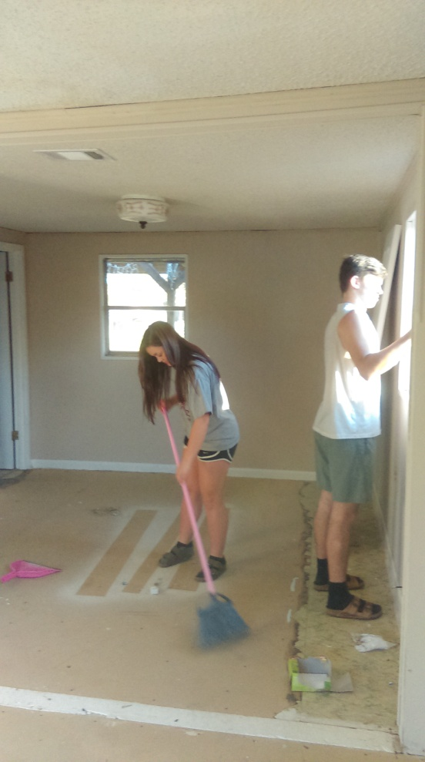

We are so excited about what God is doing in the life of one of our graduates and his precious family. When we welcomed Jon Lindros into our Exodos family of faith, we were blessed to add his beautiful wife Elicia and a full “quiver” of blessings who now serve the Lord alongside their mom and dad. Jon grew in the Lord at Exodos in 2013, where he also began work with Oliver’s Nurseries through Exodos work program. Jon worked hard, gained trust and became a crew chief. Now, the Lindros clan not only faithfully attends Woodlawn Baptist Church, but also got involved with Rise To Unite (RTU) in 2016. Jon has recently been named President of this vital ministry. RTU provides exciting outreach venues and events to unite Christians in creatively sharing Christ with our community. Jon and Elicia are passionate about leading “Christians not

denominations” to partner

together as the body of

Christ to evangelize the lost.

If you are interested in

finding out more about RTU

please contact:

Jon : 850-612-1641

Elicia: 850-503-9127

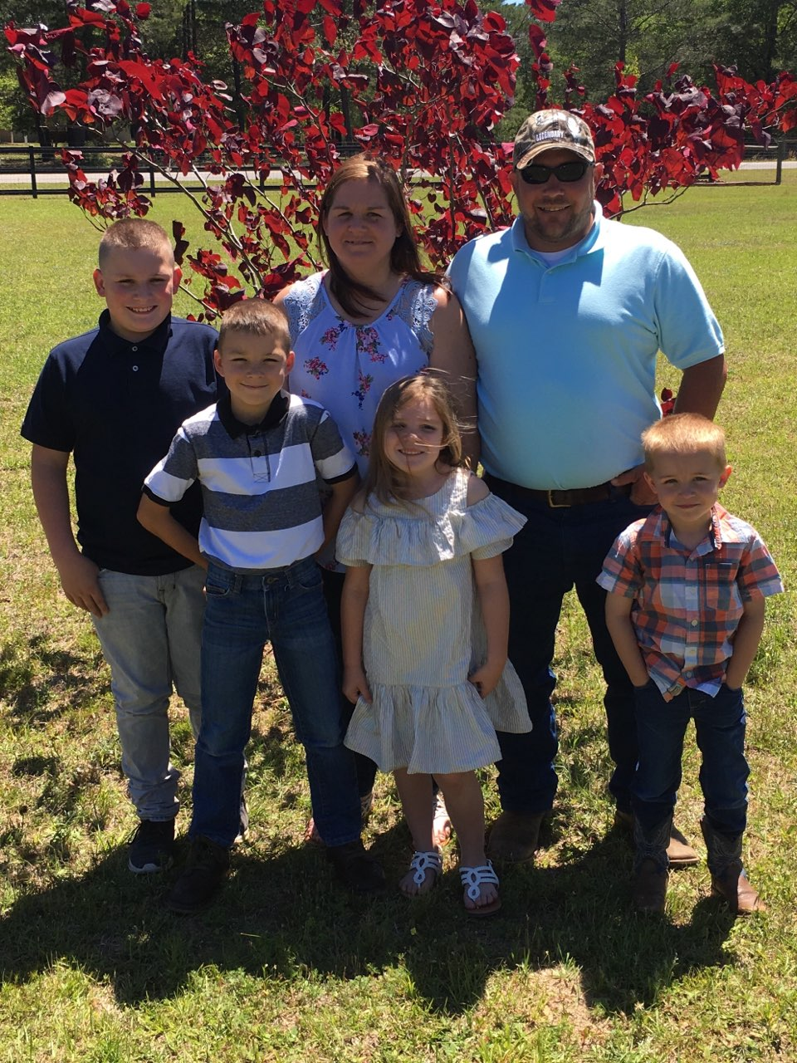

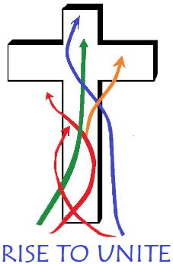

We also had several Sunday school classes and life groups pitch in to buy doors, paint and other supplies! God uses His people for His purposes!

We praise God for co-laborers in Christ from Woodlawn, Mosaic and FBC Holt who faithfully helped remodel our pastor’s home at Exodos. Amazing blessing!!!!!!!!!!!!